Rick Kaplan Wireframe:

**Navigation Bar:**

Logo(click to the home page)

About

* Services – what KPM does(statistics,examples etc.)
* Awards + Recognition – Rick Kaplan’s awards
* Rick Kaplan – bio on rick

Media

Clients

Contact

Website Nav Bar Layout:

1. **Home Page**
   1. description of Kaplan Media: ***KAPLAN MEDIA PARTNERS***is dedicated to producing quality news programming as either a network consultant or contractor, and structured to assist private industry as it navigates the new world of social media while meeting the challenges of dealing with mainstream media. KMP will deliver media training, crisis management and work with firms who are looking to increase their influence with groundbreaking conferences and intra-corporate communications.
   2. Images – 4-5

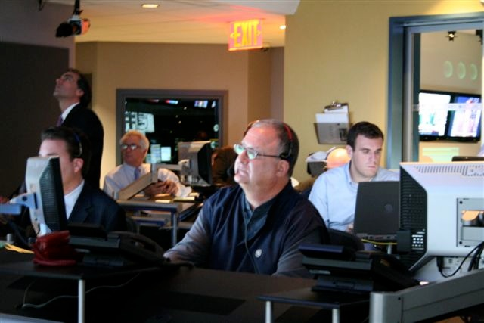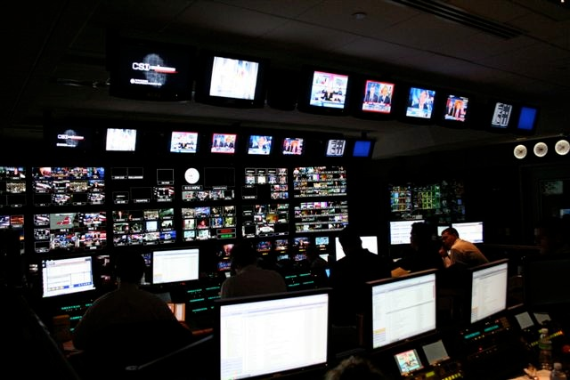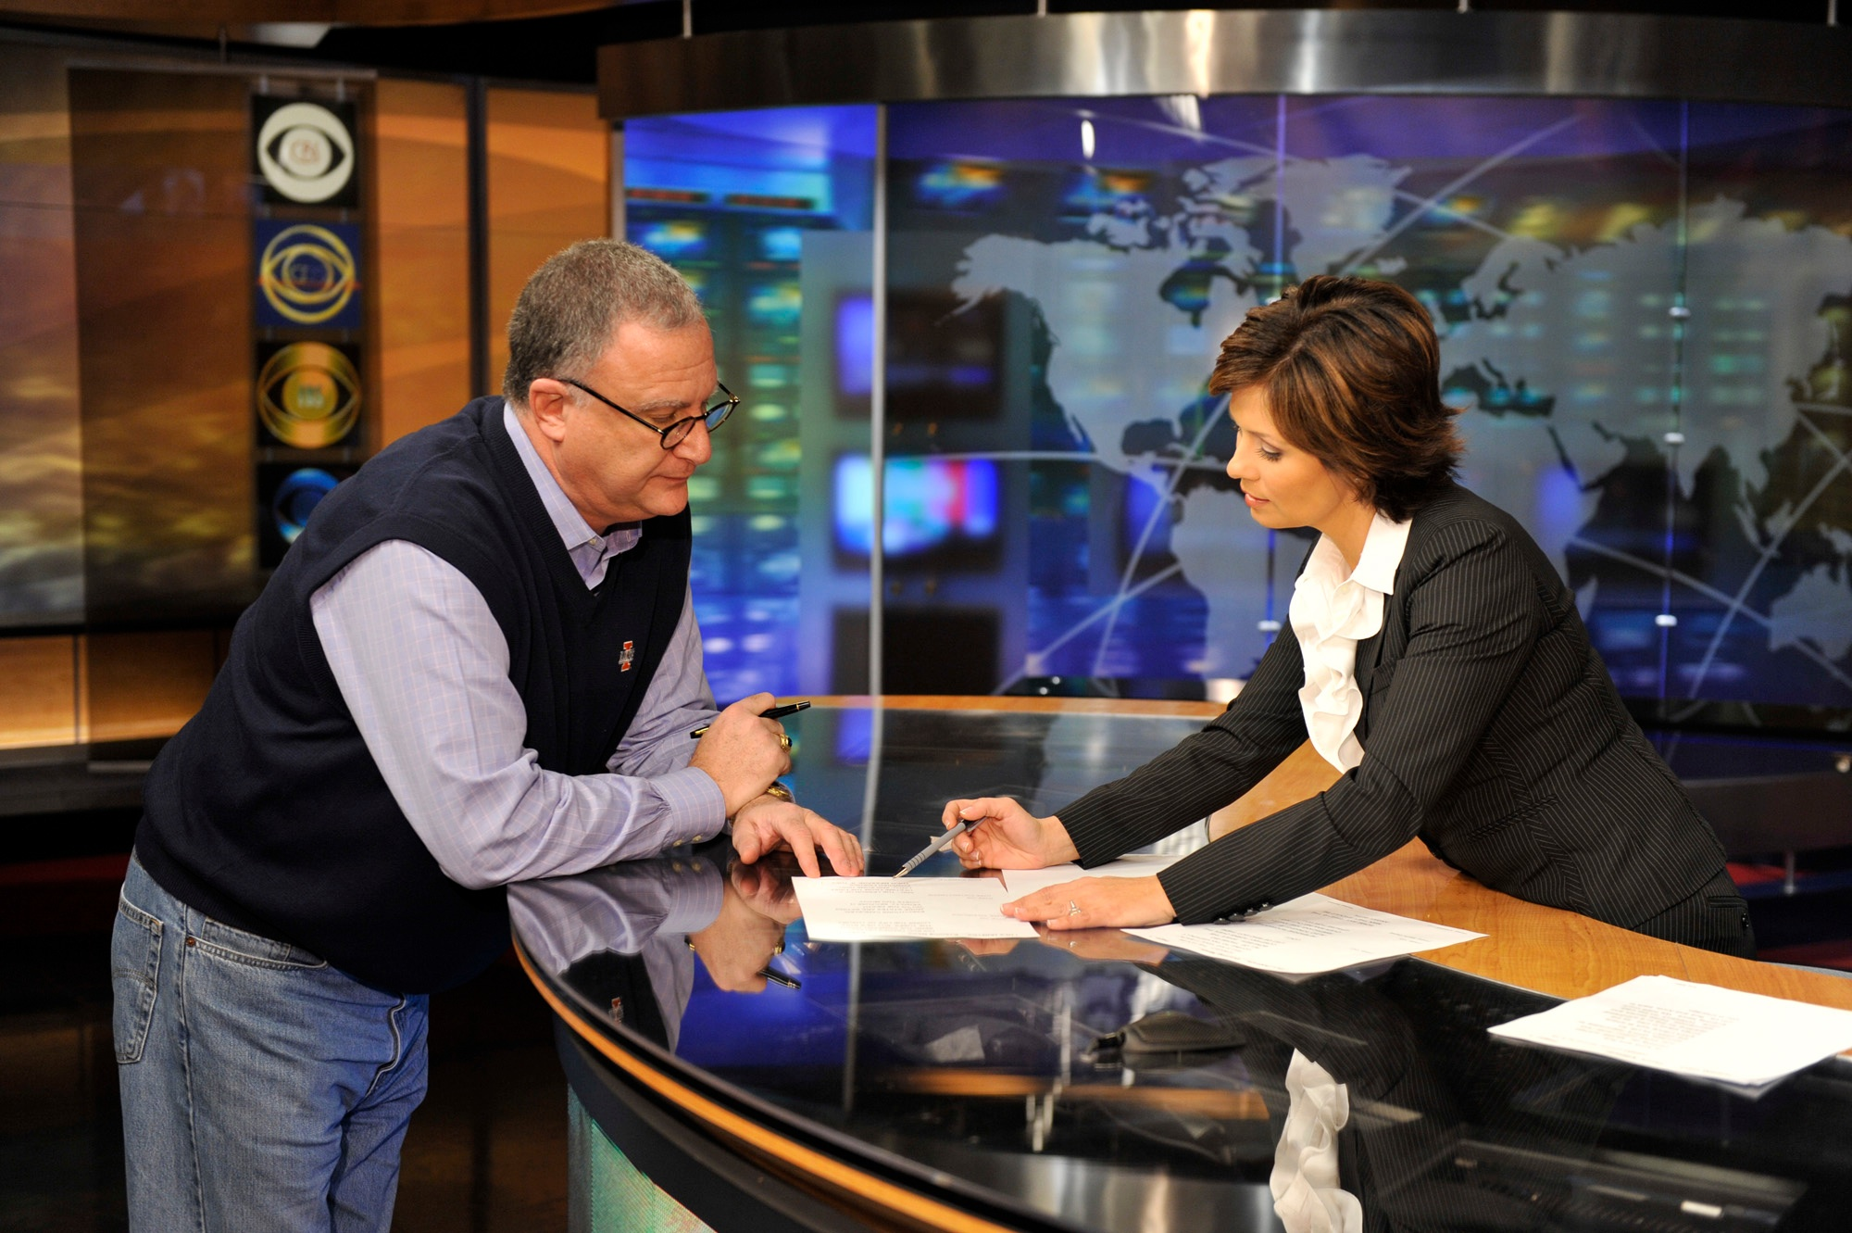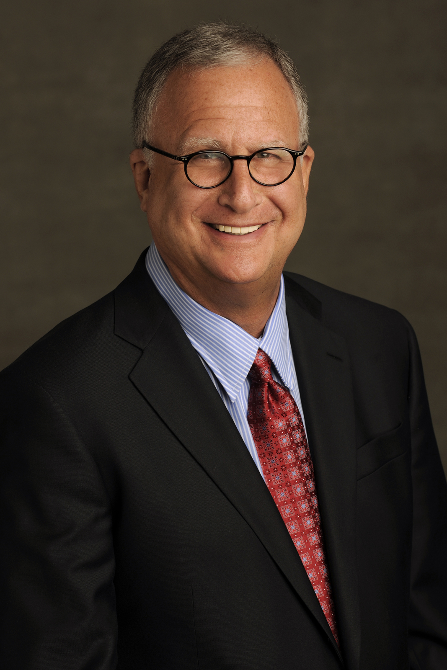

**- - - -**

1. **About (**the *italicized* options below will be dropdown menus under the ‘about’ section**):**

***Services:***

Kaplan Media ***KAPLAN MEDIA PARTNERS***is dedicated to producing quality news programming as either a network consultant or contractor, and structured to assist private industry as it navigates the new world of social media while meeting the challenges of dealing with mainstream media. KMP will deliver media training, crisis management and work with firms who are looking to increase their influence with groundbreaking conferences and intra-corporate communications.

Need: more info about KPM, have this description vary slightly from the home page, think about what you would like to showcase here good items would be specifics of the services KPM provides (what is listed above is more of a general overview), statistics you are proud of that showcase the success of working with you, maybe mention that working with KPM is working with Rick directly

***Awards + Recognition:*** *put the awards into a list format for quick easy viewing*

Richard Kaplan has received numerous awards for his work, including **47 Emmy** Awards, 4 Overseas Press Club Awards, 3 George Foster Peabody Awards, 2 George Polk Awards, 4 Ohio State Awards, 4 Alfred I. DuPont-Columbia University Awards and 2 Gold Batons, 12 Headliner Awards, 8 Cine Eagles for Journalistic Excellence and the Distinguished Service Award and Bronze Medallion from the Professional Society of Journalists, Sigma Delta Chi.

***Rick Kaplan-bio:***Here we will need to take the CV chop it up and then cut it down. I think 5-7 paragraphs would be ideal then call out specific career achievements that relate to Kaplan’s forward thinking mentality, disrupting the industry for the better, success stories etc. Maybe the information is best set out in more of a timeline format with short descriptions of his successes during each period… **Caroline** – could really use your expertise in putting together the information for this section

*Richard Kaplan has been a broadcast journalist for more than 40 years for four major news networks, in positions ranging from field production and news coverage to senior decision-making and program creation. In addition, for more than 15 years, Mr. Kaplan has been actively involved with journalism departments at a number of leading universities, teaching, lecturing and working as a Fellow. He now heads a consulting and production company that he founded, KAPLAN MEDIA PARTNERS, which works with a variety of communications companies, in television networks and in digital platforms. Kaplan also works with corporations to develop media strategies to better communicate with their own employees and clients and with the business world at large.*

**Chairman,** *Kaplan Media Partners* May 2012-Present

**Creative Consultant**, *HBO's* *The Newsroom* Season two

**Creative Consultant and Producer,** *"41 on 41" The Life of George H Bush*Current

**Director of Production and Creator,** *MSG's fuse music network, "fuse news"* Current

**Professional Network News Positions:**

**Executive Producer,** *ABC News* Jan 2012-July 2012

**Executive Producer,** *ABC News, This Week with**Christiane Amanpour*2011-Jan 2012

**Executive Producer** in charge of Political Coverage, Specials & the 2012 Elections

**Executive Producer**, *The CBS Evening News with Katie Couric*2007-2011

**President**, *MSNBC*2004-2006

**Senior Vice President**, *ABC News*2003-2004

**Executive in Charge of Iraq War coverage**, *ABC News*2003

**President**, *CNN-US* 1997-2000

**Executive Producer**, *ABC TV Special Projects* 1996-1997

**Executive Producer**, *ABC New*s *World News Tonight with Peter Jennings* 1994-1996

**Executive Producer**, *ABC News Primetime Live* 1989-1994

**Executive Producer**, *ABC News Nightline* 1985-1989

**Executive Producer**, *Good Morning America News* 1984-1985

**Senior Producer**, *ABC News World News Tonight* 1979-1984

**Associate Producer**, *The CBS Evening News with Walter Cronkite* 1974-1979

**Associate Producer**, *The CBS Morning News* 1971-1974

**Writer, Assignment Desk Editor & Producer**, *WBBM-TV Chicago*1969-1971

**Harvard University**

**Adjunct Fellow**, *John F. Kennedy School of Government, Shorenstein**Center* 2003-Current

**Fellow**, *John F. Kennedy School of Government, Shorenstein* Center 2001-2002

**Visiting Lombard Lecturer**, *John F. Kennedy School of Government*  2001

**University of Illinois**

**Adjunct Professor of Journalism** 1998

**- - - - - -**

1. **Media** – here we can showcase media clips from Rick Kaplan as well as from things he has worked on with KMP, positive press coverage of rick Kaplan and of his work with KPM. Basically the links that Caroline put together.

**- - - - -**

1. **Clients** – list the clients with a little blurb about the work that was done (help increase viewership, came in to change audience, work with social, change content etc.)

**- - - - -**

1. **Contact** – contact form to reach out to Rick